Evaluation of average quality of 100 repetitions for different iteration numbers
E = [3, 2, 1, 1, 0, 0, 0, 0, 0, 0, 1, 1, 2, 3, 4, 5, 5, 6, 6, 6, 6, 5, 5, 4]
K = 24
Bmin = 10, Bmax = 30, Bstart = 20

No penalty
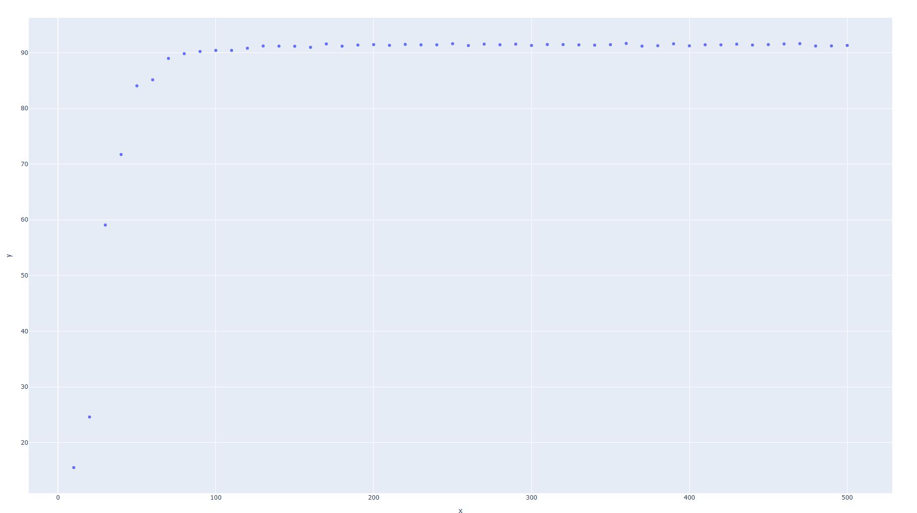

Penalty sqrt
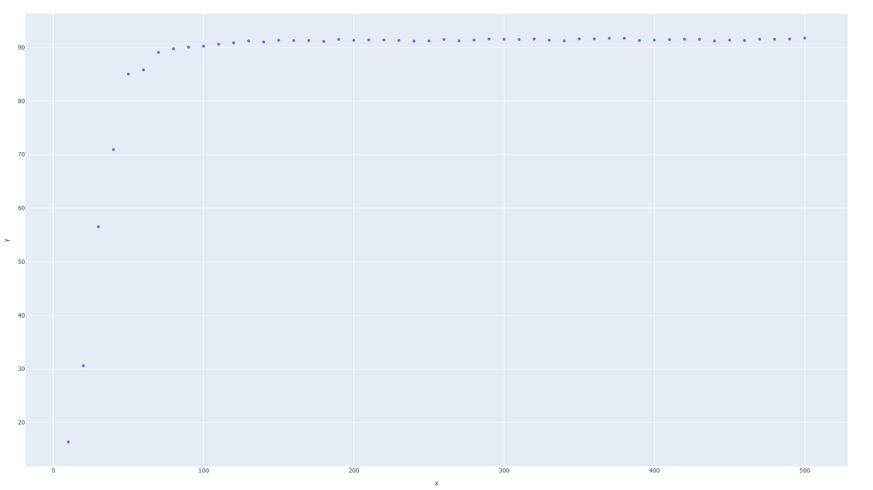
Penalty log
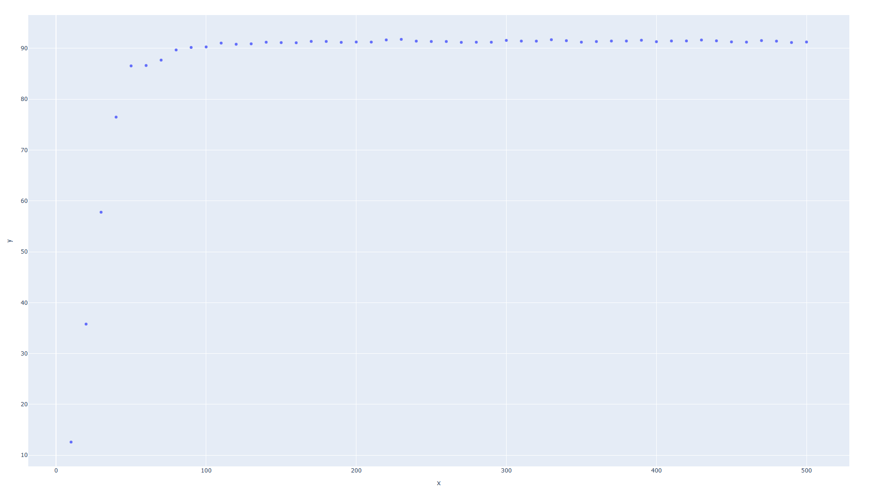

Penalty exponential to difference to start, values in edges

Linear UCB for best child: 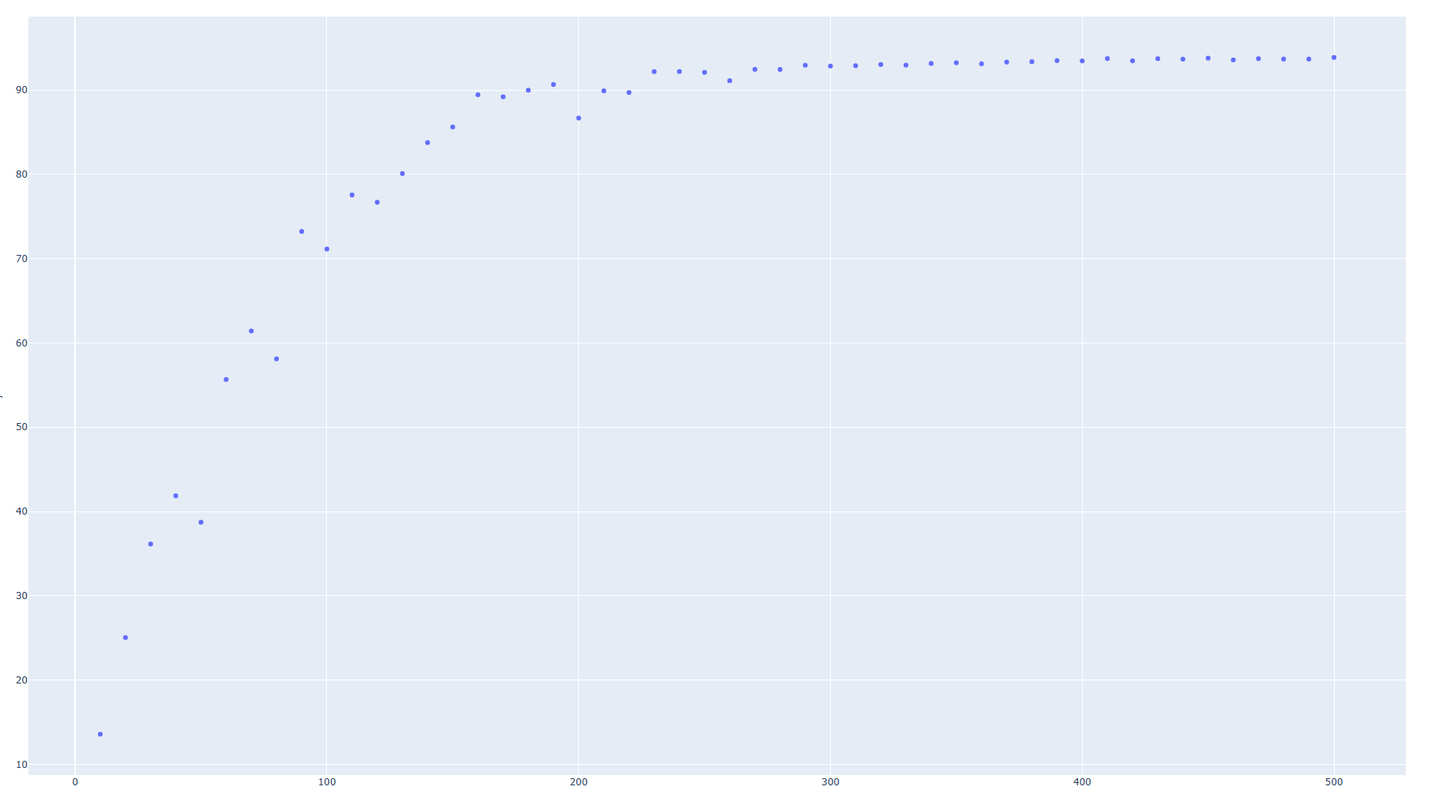
UCT:
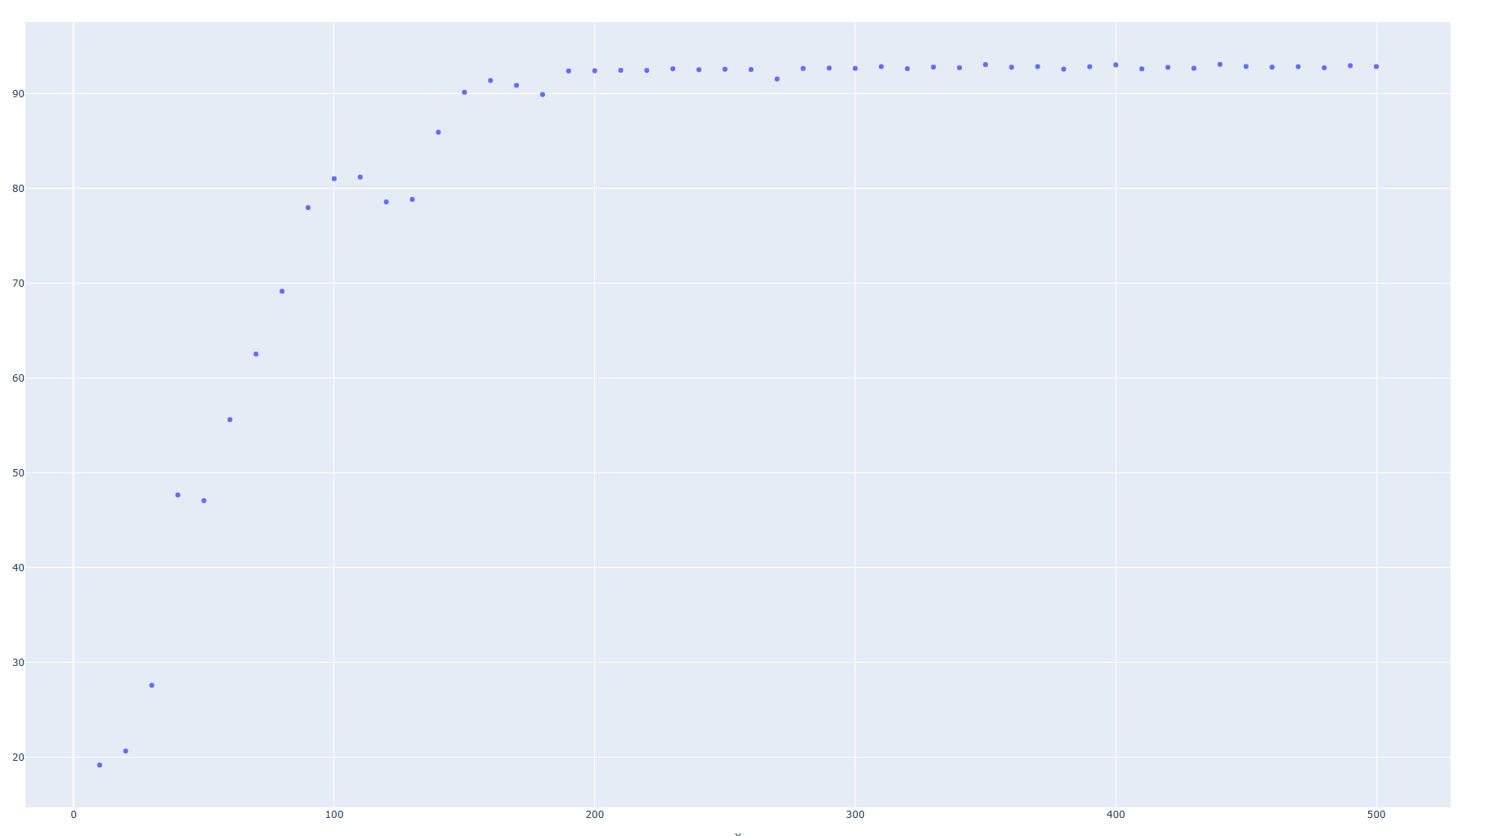

Values in nodes:
Linear UCB:
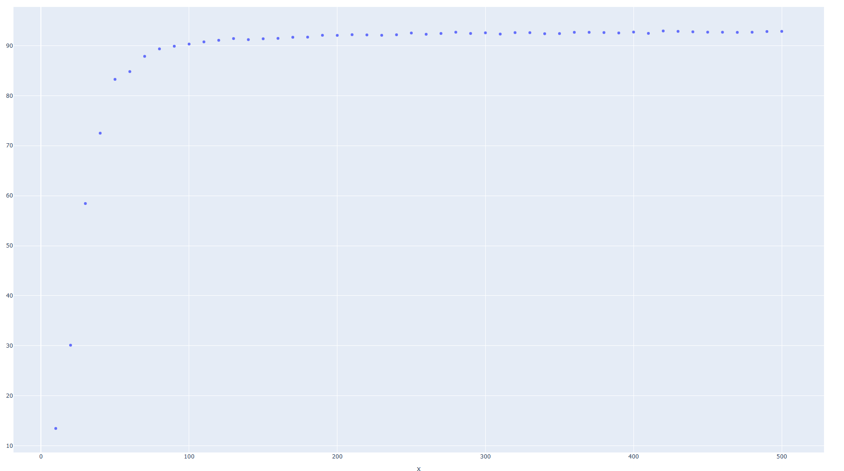
UCT:
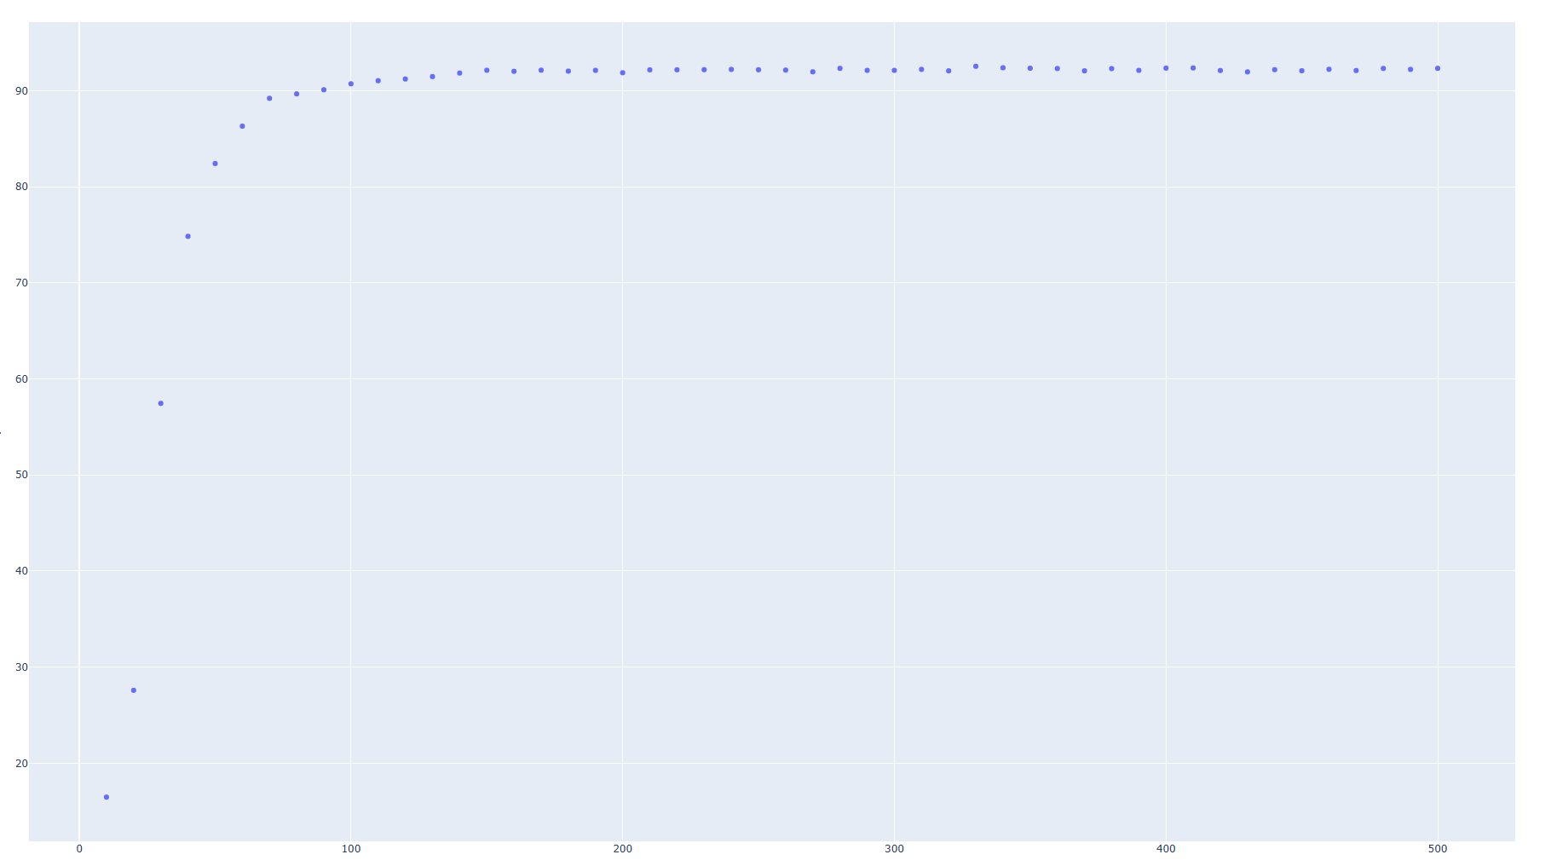
No exploration parameter:
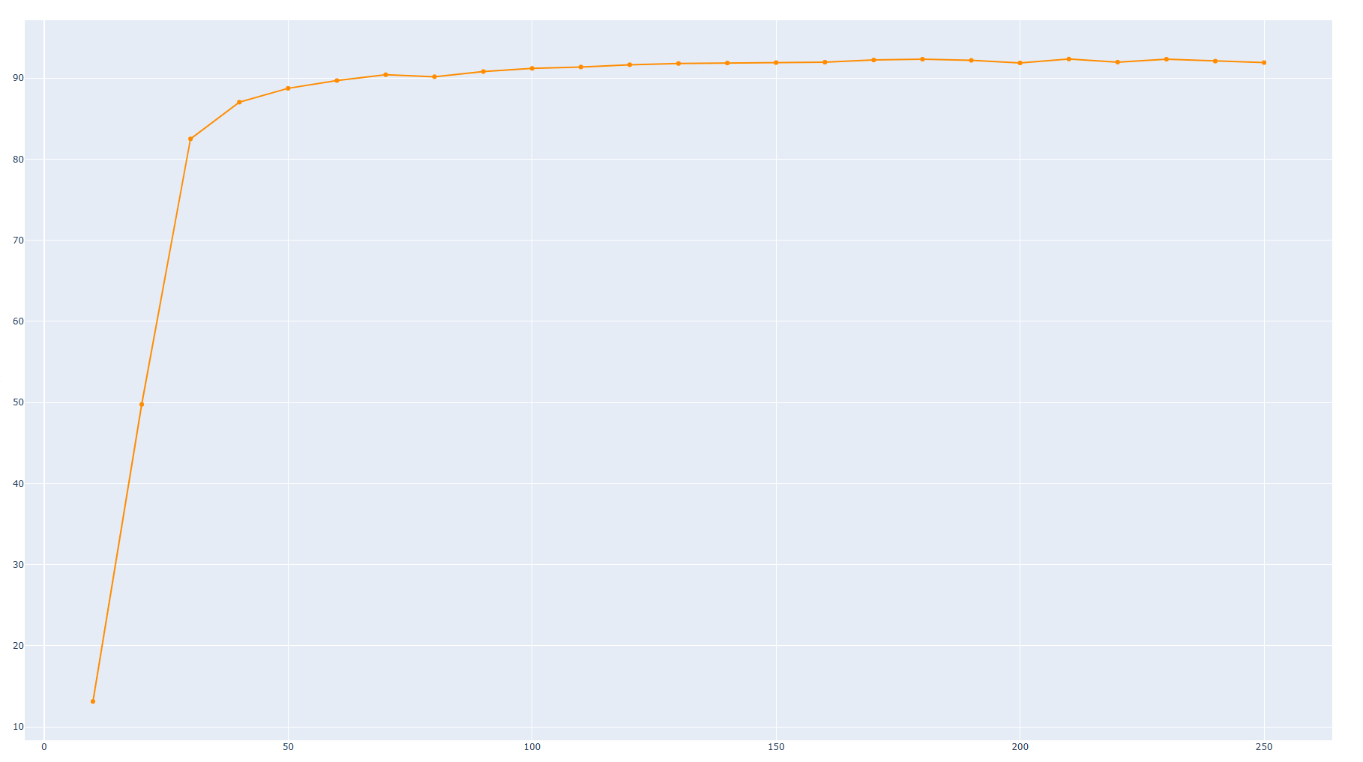

Overall:
- Not much of a difference between UCT and linear UCB
- Values in edges reaches plateau later, which might also be due to the different selection/expansion logic
- Nodes in edges with linear UCB keeps slightly rising after plateau and reaches the highest overall values
- Ovr: nodes in edges not worth it, rather use no exploration parameter, as it reaches high values much earlier

Penalties:
Exponential with k=1:
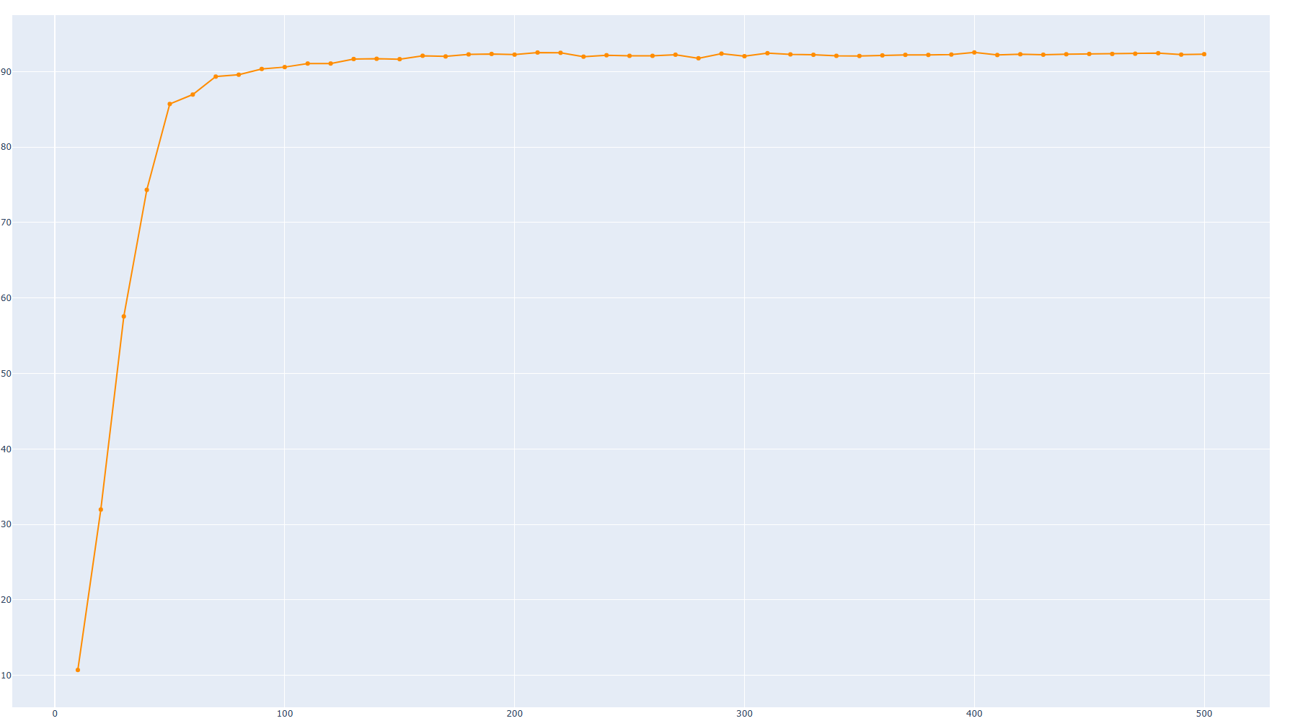
Linear with factor 2:
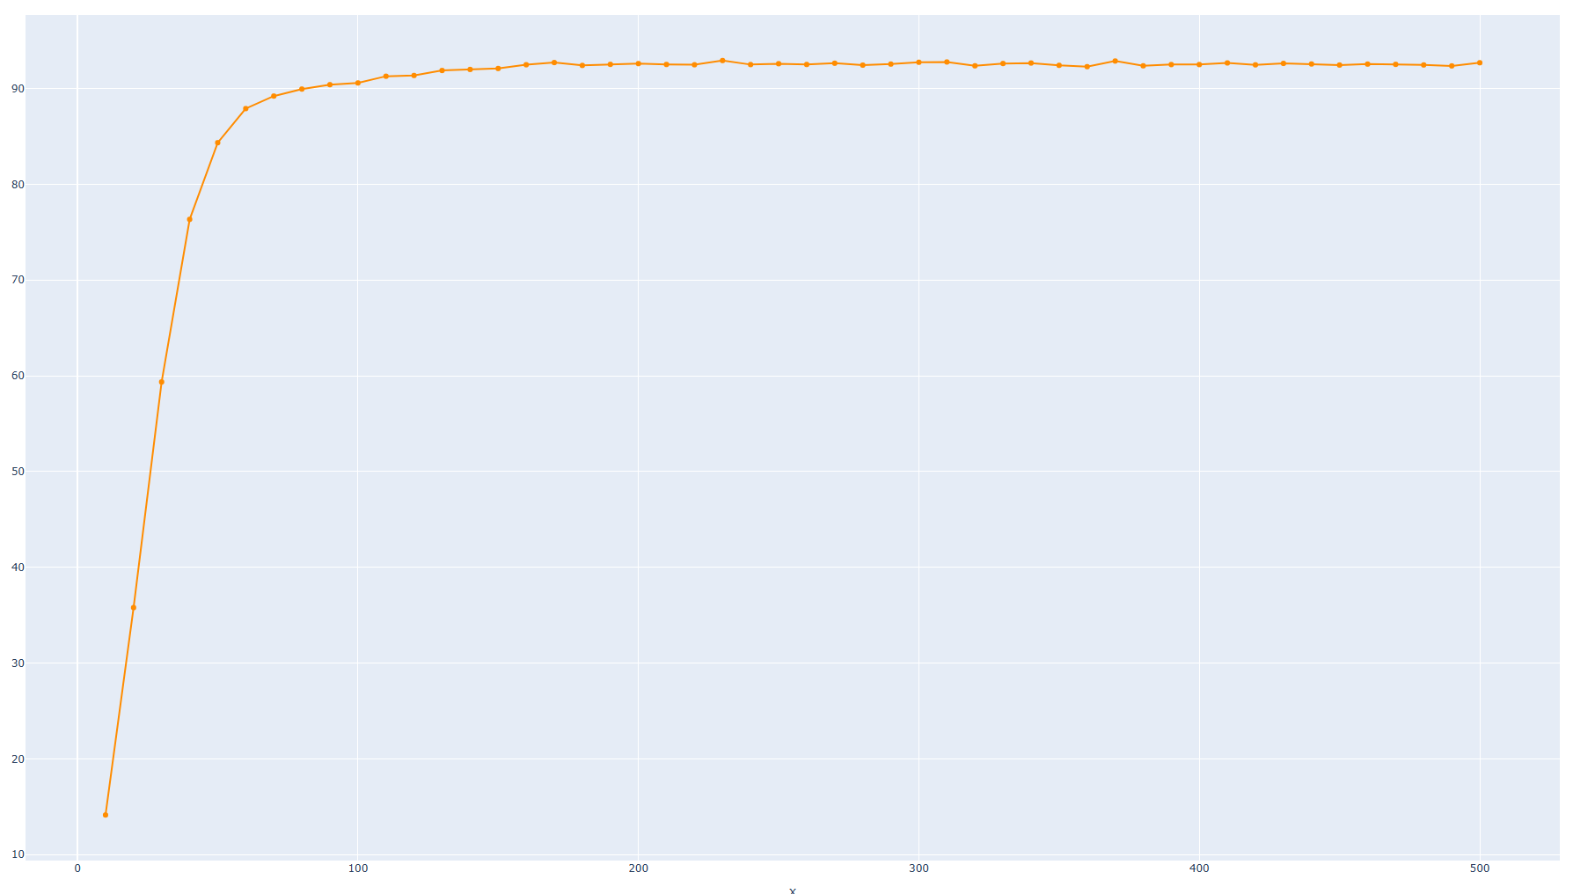
Ovr basically the same, linear might even be slightly (~0.2) better on average

Adressing exploration problem: too high values for exploration param

Penalty 0:
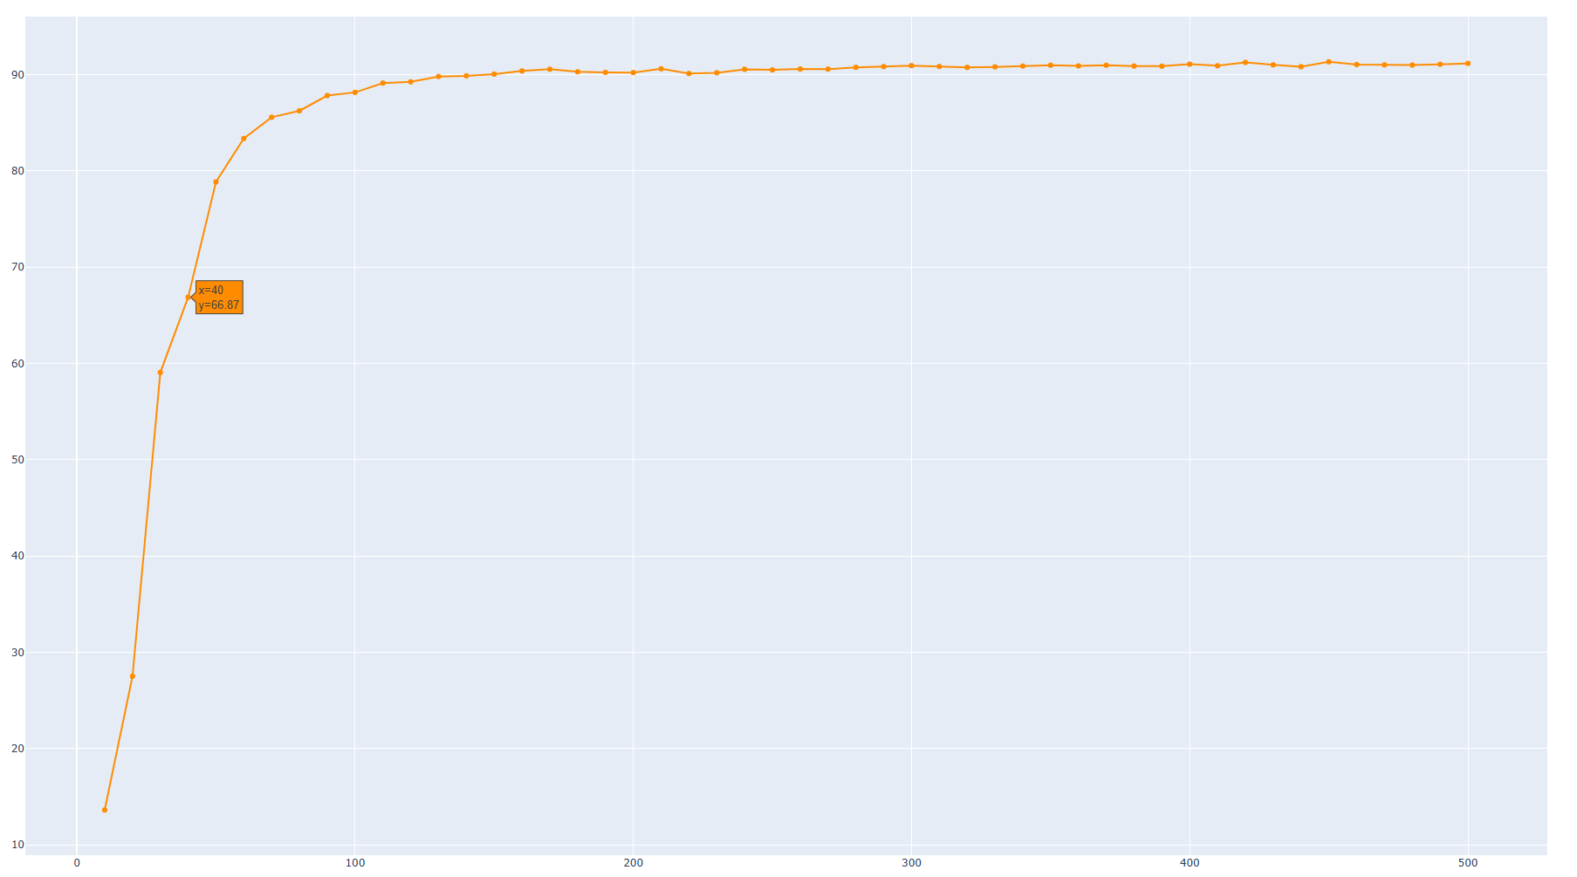

Linear penalty:
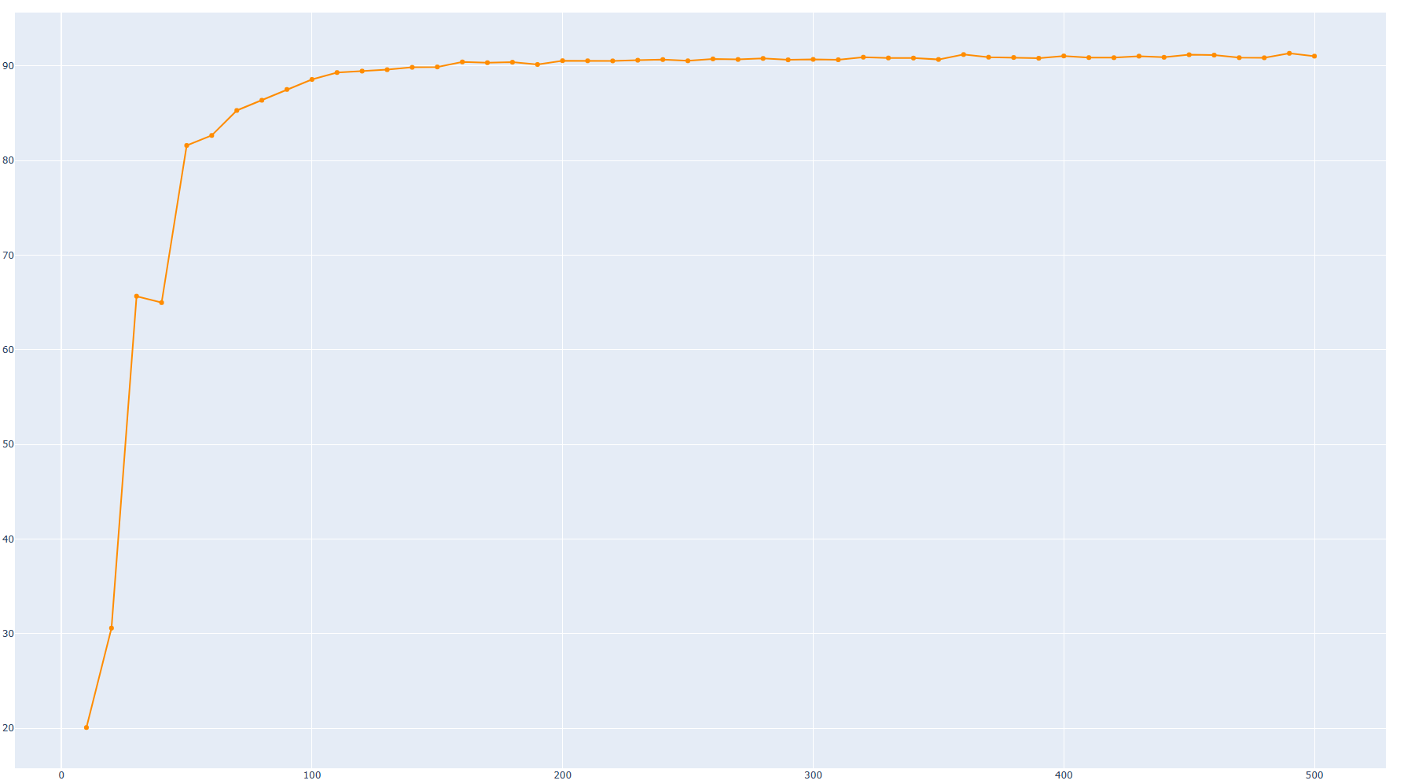

Exponential penalty:
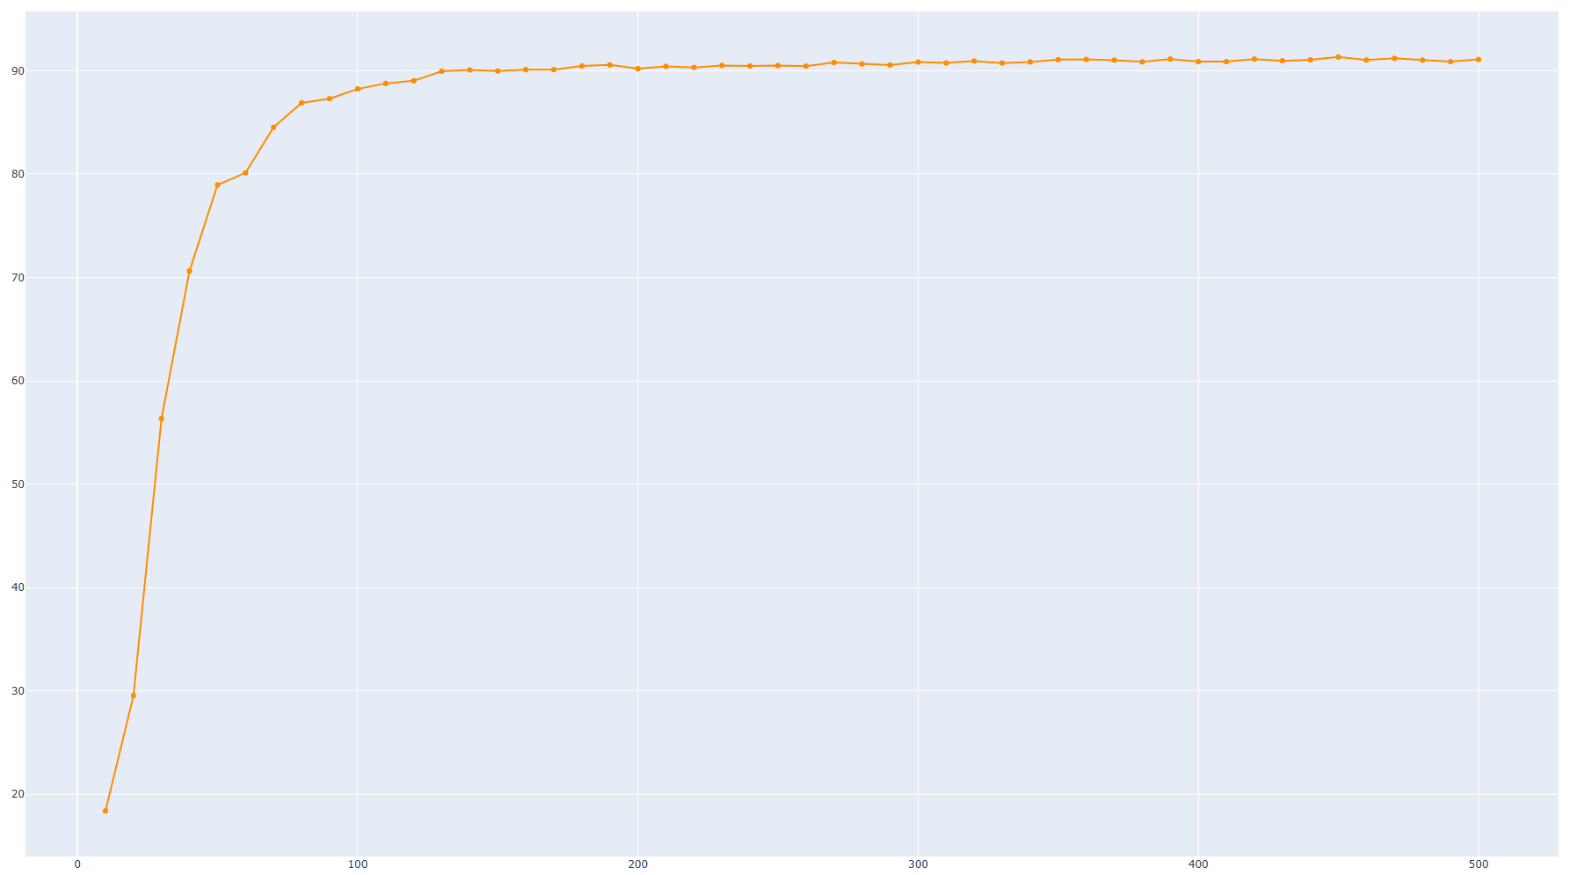

- May rise a bit, but ovr quality clearly lower than without normalization
- No significant difference between penalty methods
- > in this form not viable
